
LESSON NOTE | DETAILED EXPLANATORY NOTES
BIOENERGY
PAPER BATTERIES
GRADE 12 - BIOLOGY
■ ■ ■

What is a Paper Battery?
A paper battery is a thin, flexible battery built on ordinary paper. Because paper is made from cellulose - the fibre from plant cell walls - a paper battery is largely made from plant material, making it a type of bio-battery. The paper is soaked in an electrolyte and sandwiched between two thin electrodes; some designs also use lignin, another plant substance, which can store and release electric charge. Paper batteries are light, bendable and biodegradable.
This lesson looks at what paper batteries are, the plant materials they are made from (cellulose and lignin), how they store charge, and where they might be used - including their potential in Papua New Guinea.
Why Paper Batteries Matter
- They are thin and flexible - they can bend, fold and fit almost anywhere.
- They are made from cheap, renewable plant materials.
- They are biodegradable, reducing battery waste and pollution.
- They suit lightweight, disposable electronics such as smart cards and tags.
Paper Batteries
Key Learning Outcomes
By the end of this lesson, students should be able to:
- Define a paper battery and describe its basic structure.
- Explain the roles of cellulose and lignin - the plant materials used.
- Explain how the paper acts as the electrolyte holder and separator.
- State how lignin can store and release electric charge.
- Discuss the advantages, limitations and uses, including in Papua New Guinea.
The Structure of a Paper Battery
A paper battery has a very simple, layered structure. A sheet of cellulose paper is soaked in an electrolyte and placed between two thin electrodes - often carbon, or a carbon - metal pair. The paper does two jobs at once: it holds the electrolyte and it separates the two electrodes so they do not touch. When the electrodes are connected in a circuit, a chemical reaction drives electrons from one electrode to the other, producing a small electric current. The whole device can be as thin as a sheet of paper and can be bent or folded.
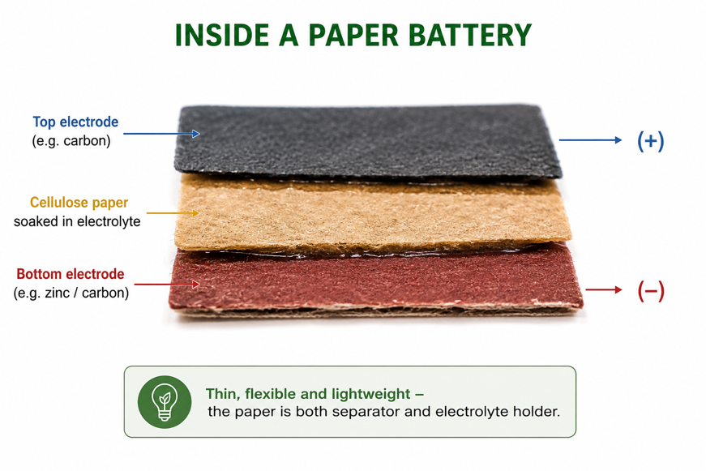
Figure 1: A paper battery - cellulose paper soaked in electrolyte sits between two thin electrodes.
Terminologies and Concepts
Useful terms for this topic:
- Paper battery: a thin, flexible battery built on cellulose paper.
- Cellulose: the fibrous carbohydrate that makes up plant cell walls and paper.
- Lignin: a tough plant substance that can store and release electric charge.
- Electrode: a conductor (anode or cathode) where the chemical reaction happens.
- Electrolyte: the ion-carrying liquid the paper is soaked in.
- Separator: a layer that keeps the two electrodes apart - here, the paper itself.
- Biodegradable: able to be broken down naturally after use.
Cellulose and Lignin - The Plant Materials
Both key materials come from the plant cell wall, so paper batteries begin with wood or other plants:
Cellulose
Cellulose is a long-chain carbohydrate that forms strong fibres. These fibres are what make paper, so cellulose provides the flexible, absorbent base of the battery - the layer that holds the electrolyte and separates the electrodes.
Lignin
Lignin is the tough substance that stiffens wood. It contains chemical groups (quinones) that can gain and release electrons, so lignin can act as a charge-storing material in a battery electrode. Because lignin is a cheap by-product of the paper industry, using it turns a waste material into something useful.
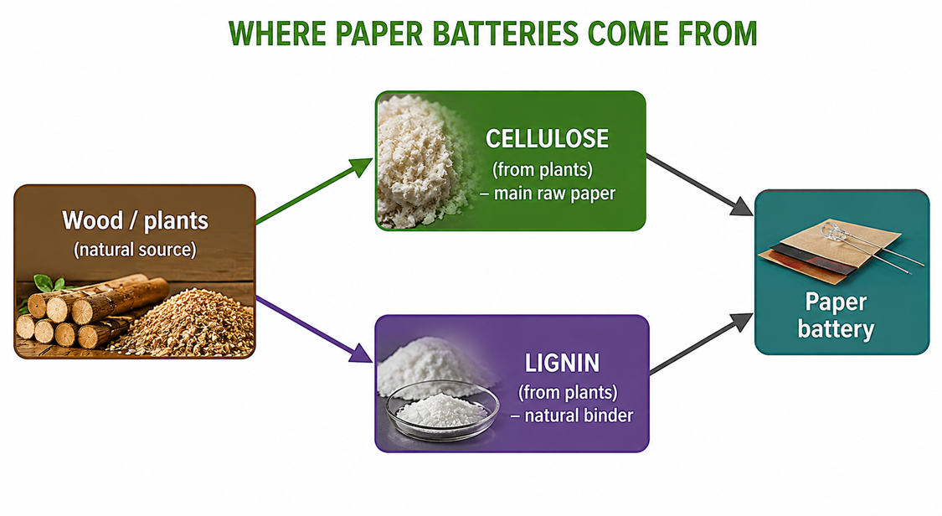
Figure 2: Cellulose and lignin from plant cell walls are the raw materials of a paper battery.
How the Paper Battery Stores Charge
Storing charge in a paper battery depends on redox chemistry - the movement of electrons. When the battery is charged, materials such as lignin take up electrons (they are reduced). When it is discharged to power a device, they release those electrons (they are oxidised), and the electrons flow through the external circuit as an electric current. The electrolyte-soaked paper lets ions move between the electrodes to keep the reaction balanced. In this way a simple sheet of treated paper can behave like a small rechargeable battery or capacitor.
Uses of Paper Batteries
Paper batteries suit any application that needs power in a thin, light, flexible form:
- Smart cards and tags - powering bank cards, ID cards and shipping labels (RFID).
- Flexible and wearable electronics - bendable displays and sensors.
- Medical devices - light, disposable sensors and patches.
- Disposable, low-power gadgets - where a biodegradable battery reduces waste.
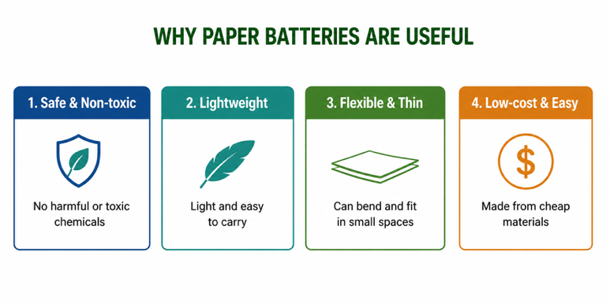
Figure 3: Paper batteries suit thin, light, flexible and disposable electronics.
Advantages and Disadvantages
Advantages | Disadvantages
Thin, flexible and lightweight | Store only small amounts of energy
Made from renewable plant materials | Can be damaged by water or tearing
Biodegradable - less battery waste | Still mostly at the research/development stage
Can use lignin, a paper-industry waste | Lower power than conventional batteries
Worked Example - Lignin Storing Charge
Lignin's quinone groups store charge by gaining and releasing electrons:
Quinone + 2 H⁺ + 2 e⁻ ⇌ Hydroquinone (charge ⇌ discharge)
Reading left to right, the lignin gains electrons (charging). Reading right to left, it releases electrons (discharging) to power a device. This reversible redox reaction is what lets a lignin-based paper battery store and give back electrical energy.
Why This Matters
- Green technology - batteries from renewable, biodegradable plant materials.
- Less waste - they reuse lignin and break down naturally after use.
- New electronics - they enable thin, flexible and wearable devices.
- Value from by-products - they turn paper-industry waste into a useful product.
PNG Context Example
Papua New Guinea has abundant plant biomass - timber, bamboo, coconut husk and other fibres rich in cellulose and lignin. In principle these local materials could supply the raw ingredients for paper-type batteries and other green electronics, adding value to forestry and agricultural by-products. As a classroom activity, students can build a simple paper or fruit battery to see how plant materials and an electrolyte can light a small LED - a low-cost, hands-on link between plant biology and electricity.
References & Related Documents
Source Documents
- STEM Biology Syllabus - Grade 12. Thema: Energy; Module 12.1 Bioenergy (Paper Batteries). Department of Education, PNG.
- Biology Standards-Based Syllabus, Grades 11 & 12 (PNG SBC 2020) - Strand 2: Life; investigate the structure of plant cell walls and the role of carbohydrates such as cellulose.
Further Reading & References
- OpenStax Biology - Carbohydrates; The Plant Cell Wall (cellulose). https://openstax.org/books/biology
- Khan Academy - Redox reactions and electrochemical cells. https://www.khanacademy.org/science

